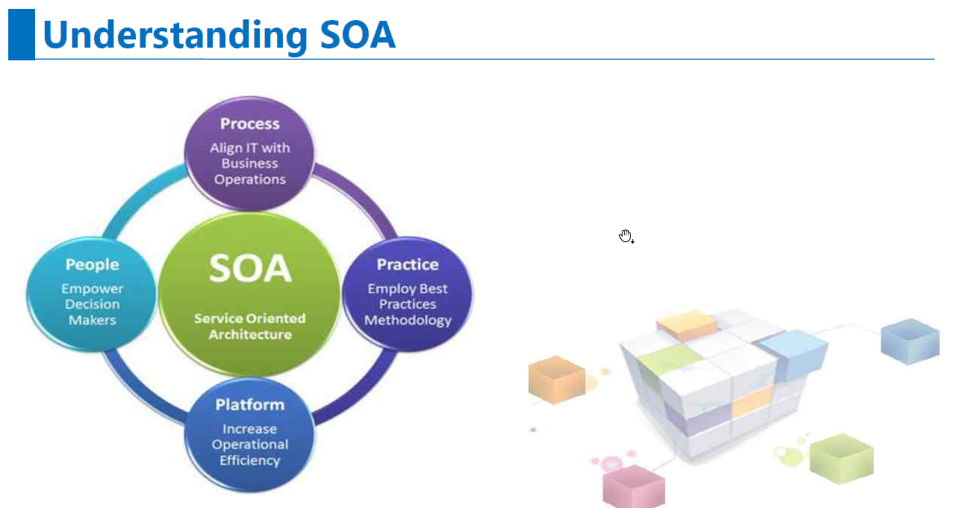

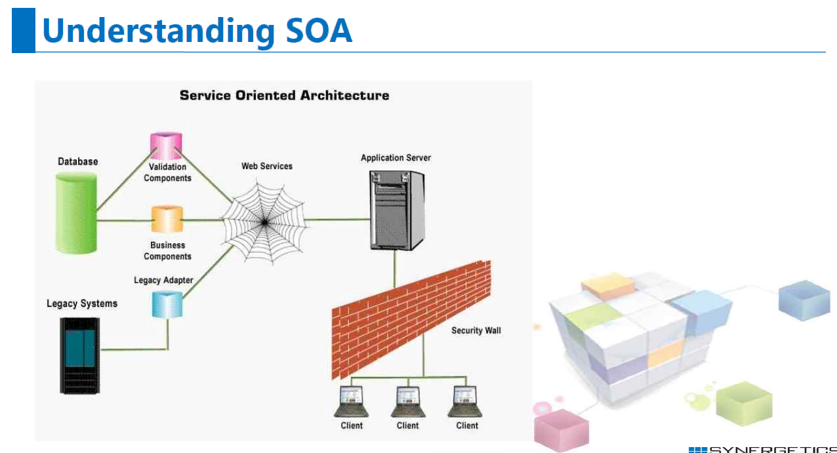

SOA Architecture

-----------------

Standard Service Contract

Service Autonomy

All the Services are independent and they control over the functionality

service statelessness

service blackboxes

Services Discovery

Service Provider?

Service Consumer?

Service Broker?

UDDI---Service Registry

service provider - expose the service;

Serive consumer - consumes the funcationality from a service.

Broker - service registry

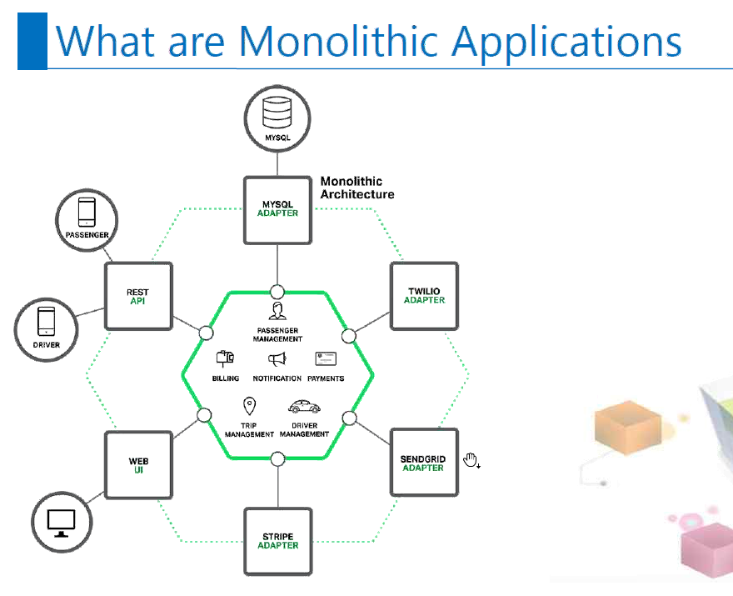

Build entire application at once. Monolithic deployed at one place.

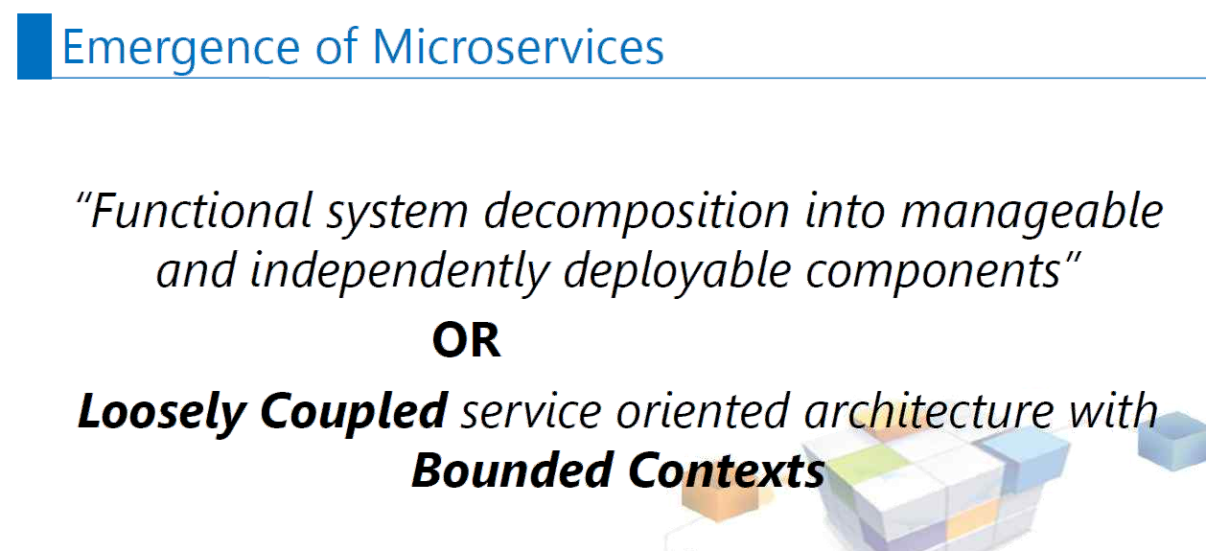

If something is independently **deployable**, **scalable** or **manageable** then we can make microservice.

If not, it is distributed monolithic.

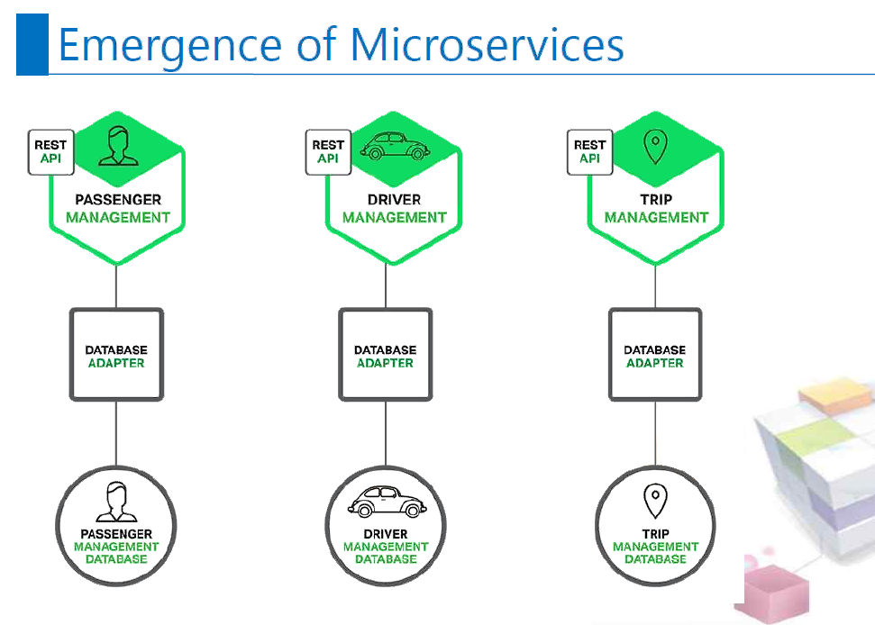

Each Microservices should have separate database. Data partition is must for Microservice.

We can create separate instance to increase the scalability.

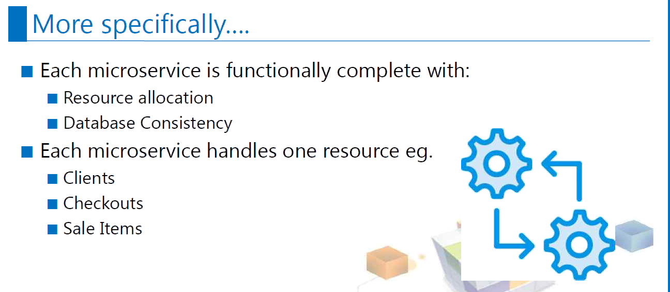

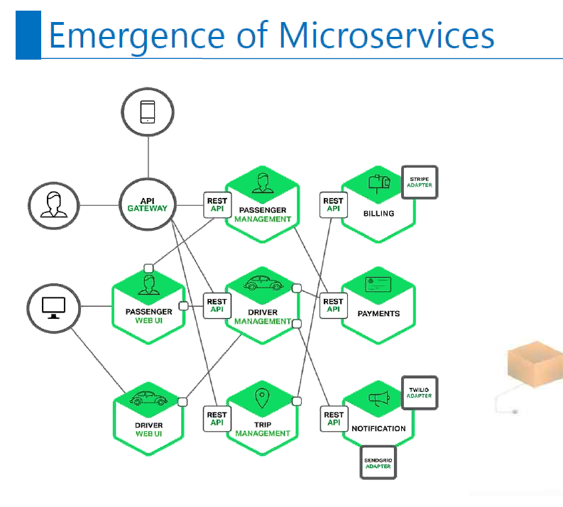

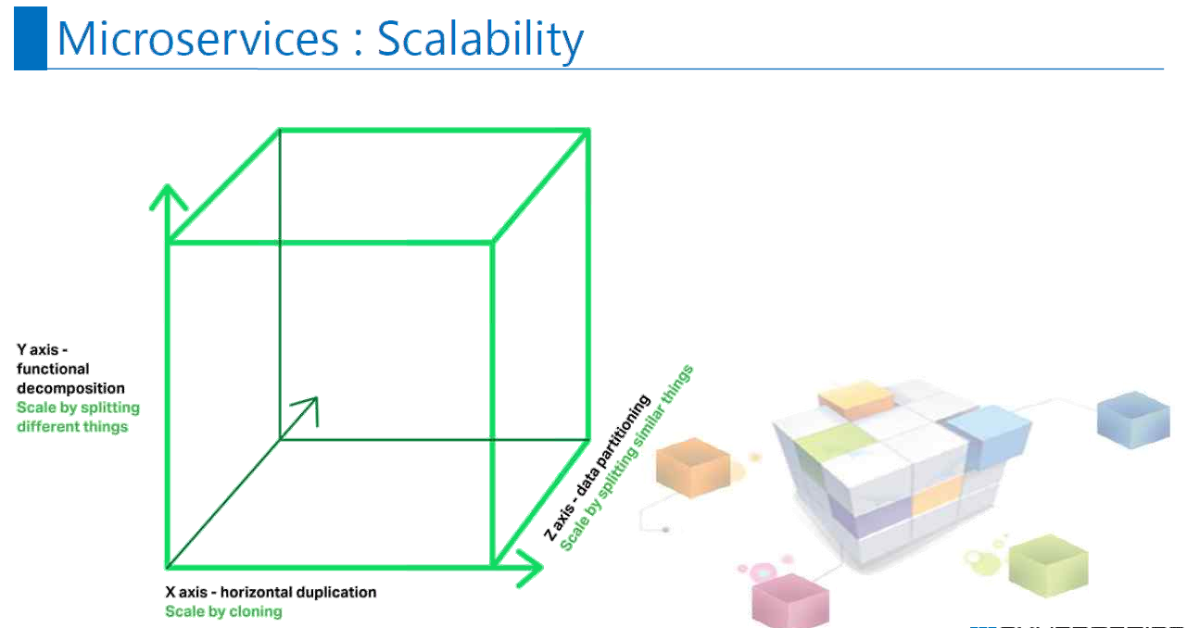  
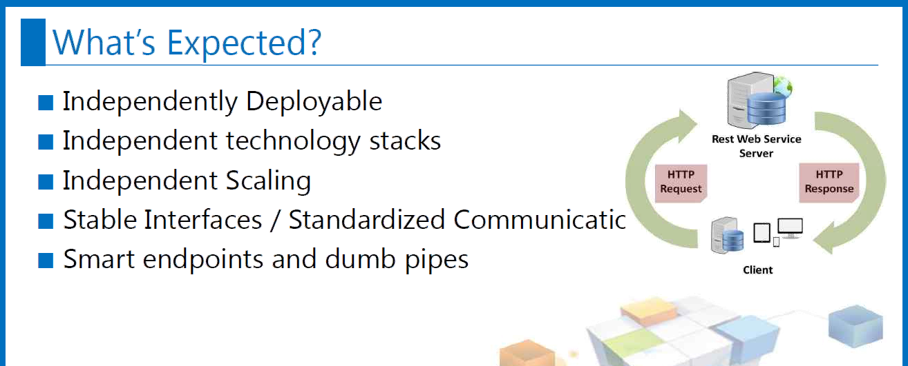



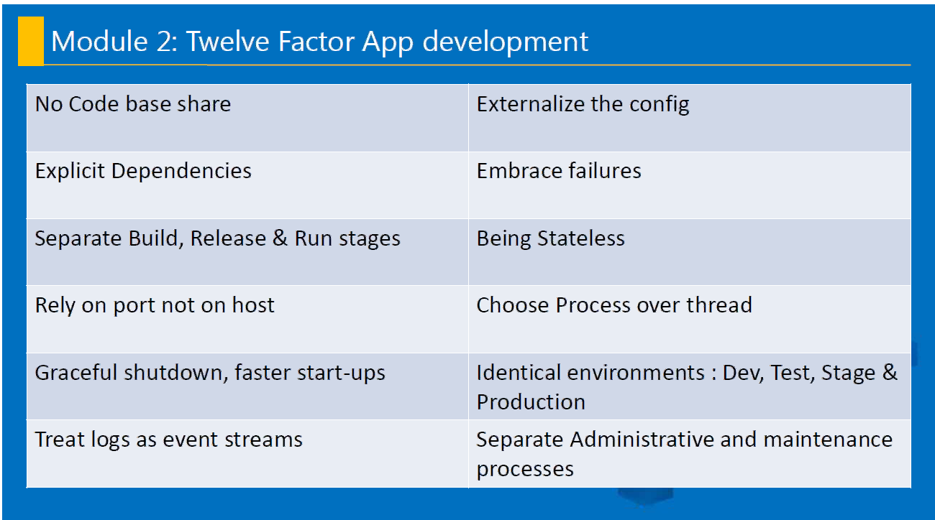

Graceful shutdown. Application goes down slowly without affecting anything.

Ex: Return in void main.

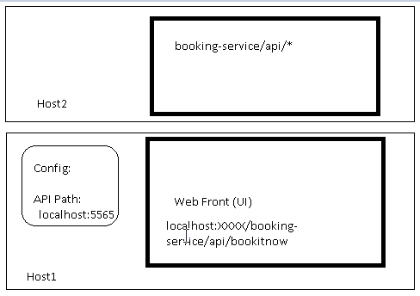

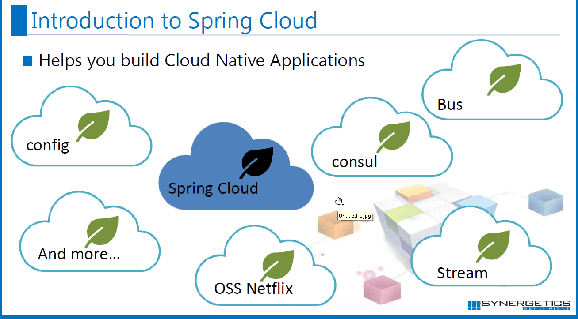

Bus—Asynchronous transfer.

Toolkit which assist us in building Microservice easily.

Spring Cloud uses Spring Boot.

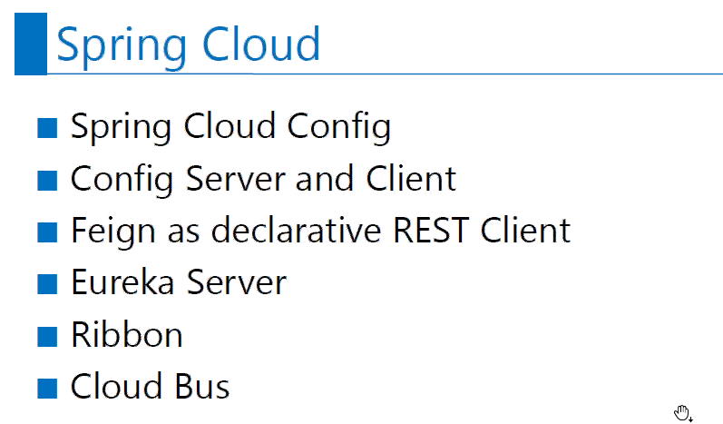

Ribbon---Load Balancer.

Eureka Server----The discovery mechanism. All microservice needs to registered in Eureka server.

It is part of Netflix OSS.

Github repository:

<https://github.com/mahendra-shinde/spring-cloud-config-repo>

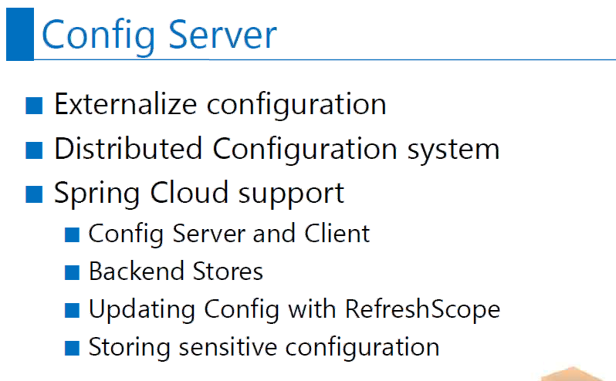

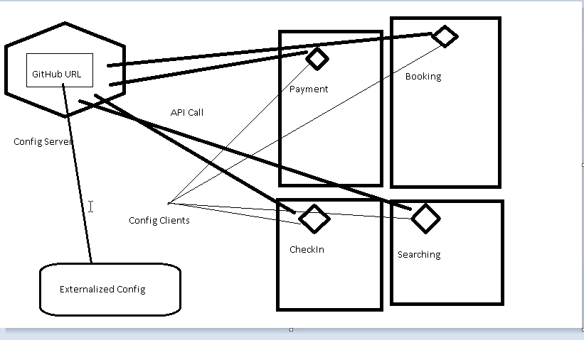

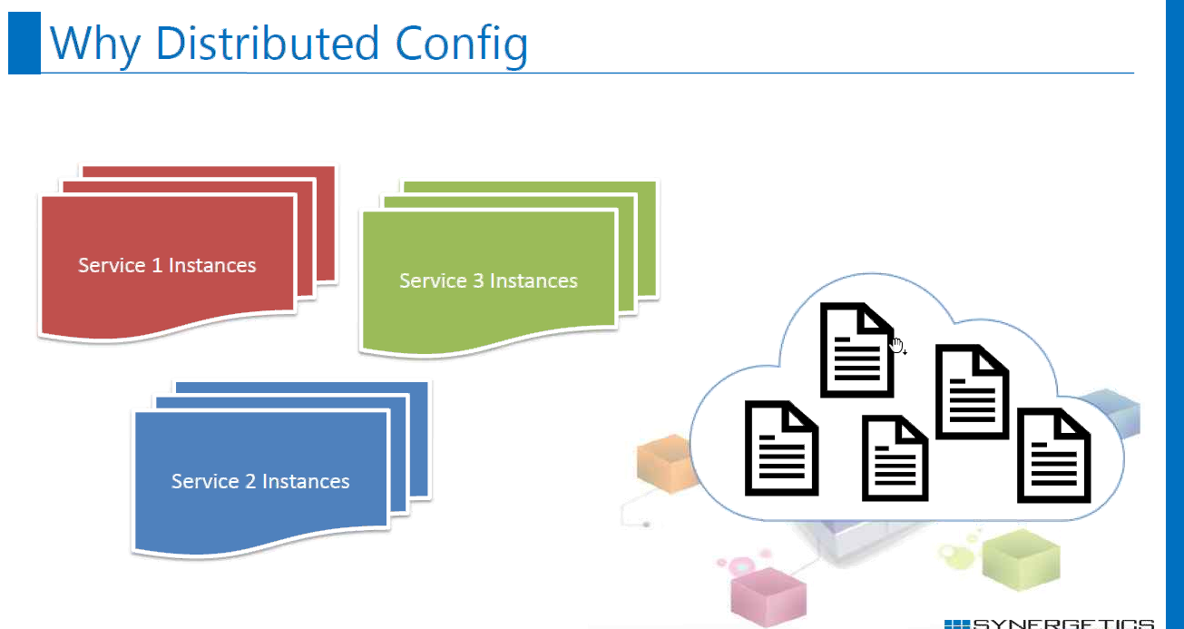

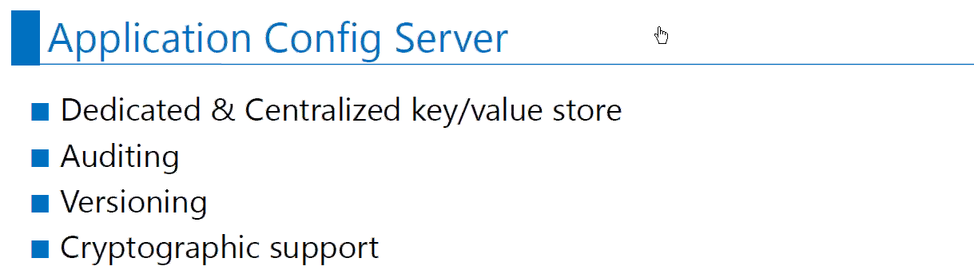

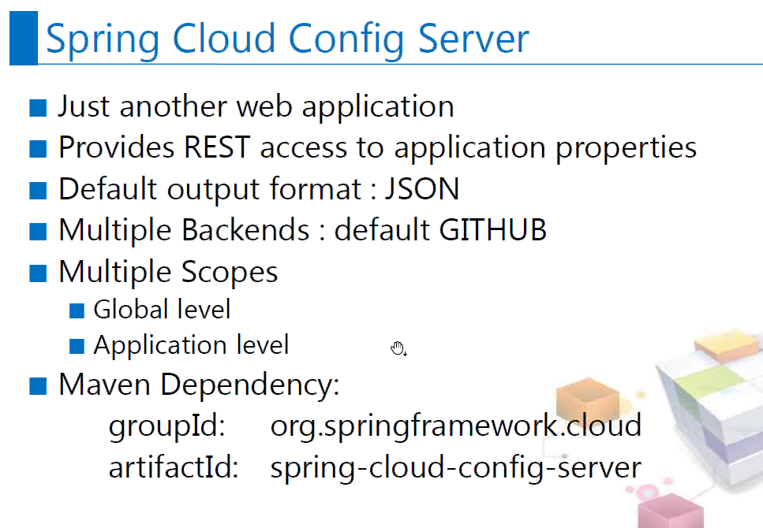

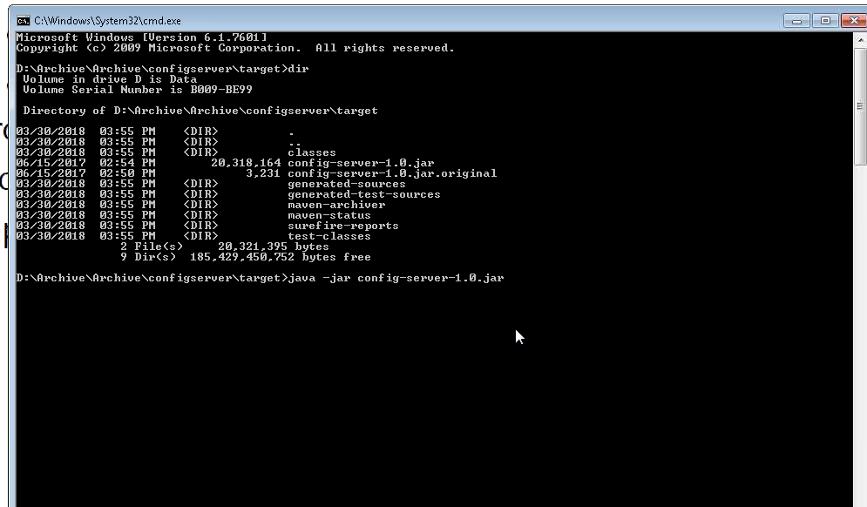

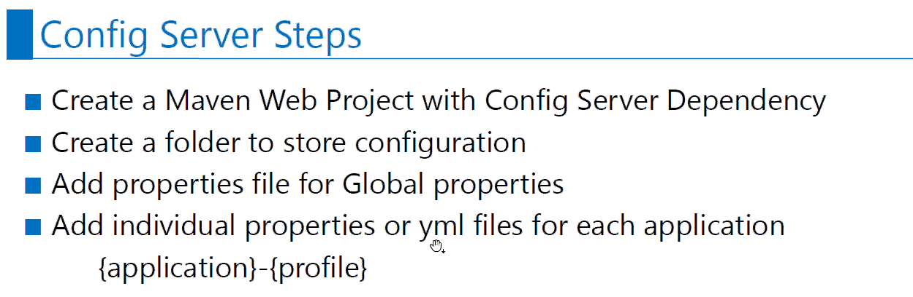

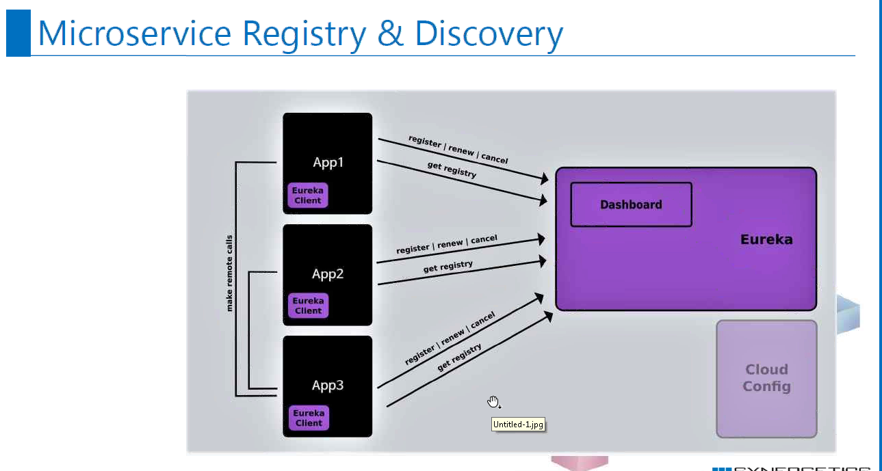

<https://github.com/mahendra-shinde/micro-services-basic>

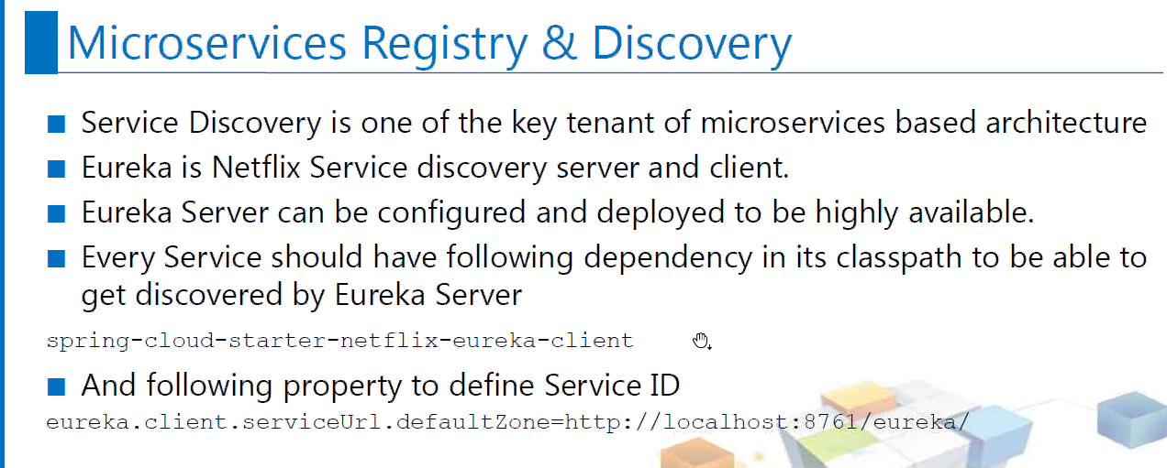

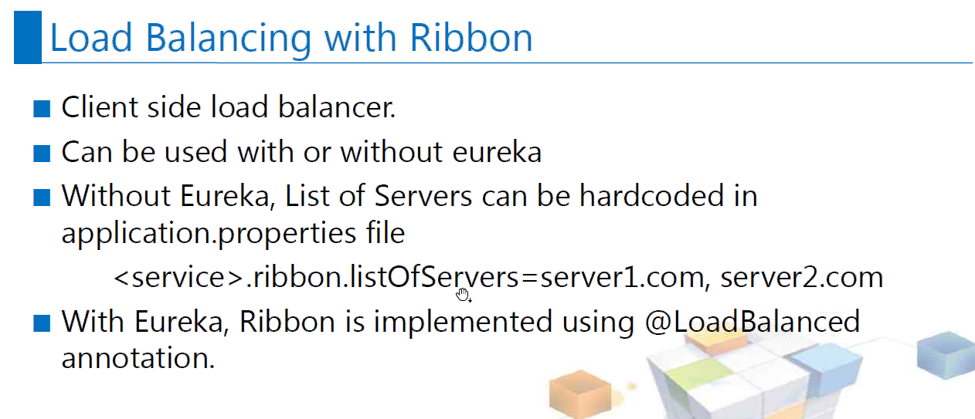

Graceful shutdown

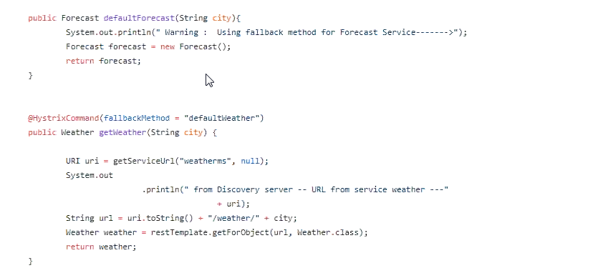

Turbine Server communicate with Eureka server to get the details about the micro service.

Netflix server is ready to use.

RabbitMQ---Messaging server

Ribbon---Load Balancer.

Eureka Server----The discovery mechanism. All microservice needs to REGISTER in Eureka server.

It is part of Netflix OSS.

Synergetics-live.com

synergetics-india.com

MahendraShinde@synergetics-india.com